MAKE WINE AT WITCHMOUNT !
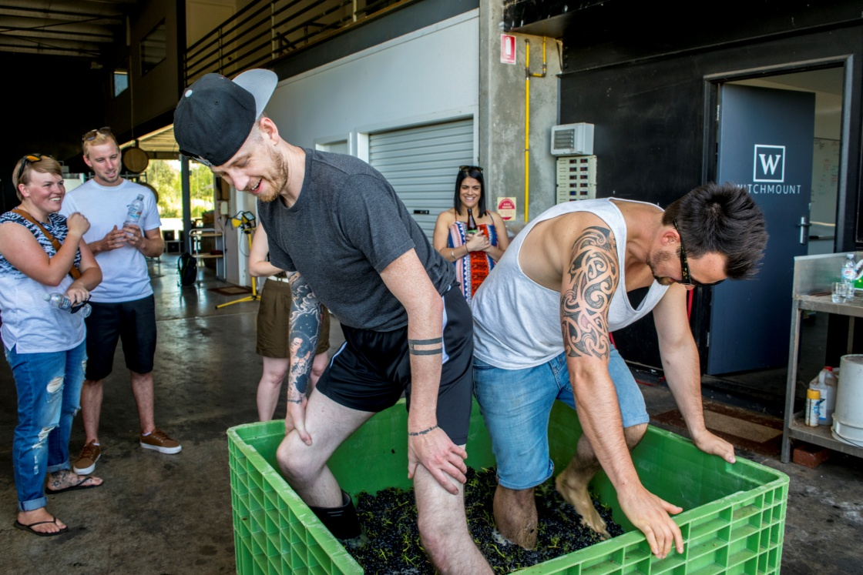

This vintage at Witchmount we are offering you the chance to make your own wine!!

You will get to pick the grapes with your own hands, stomp them with your own feet and take home the fruits of your labour to enjoy!
For just $135 per person you will experience the whole winemaking process over three days in 2017.
Day 1: You will spend a Saturday morning in March picking grapes, followed by an afternoon of foot crushing and a BBQ.
Day 2: You will then attend a Saturday in May of barrel sampling to check on the progress of your wine and make decisions on blending options.
Day 3: A Sunday in November you will bottle the wine followed by a long afternoon lunch.
You will also get to keep 6 bottles of the wine that you made!!
There are a very limited number of spots available so be sure to book your tickets ASAP.
For further info please call 97471055 or email ben@witchmount.com.au

